4.1 test ms

1. (a) (i) Rate = k[X][Y]2 (2)
(ii) 3 (1)
(iii) 8 (1) 4
(b) (i) Overall order of reaction 2 (1)
Explanation doubling both [A] and [B]
leads to Rate × 4 (1)
(ii) Order with respect to B 0 (1)
Explanation doubling [A] at constant [B]
also leads to rate × 4 (1)
(iii) Rate = k[A]2 (1)
(iv) k = 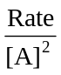 = 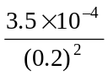 (1)
= 8.75 × 10–3 dm3 mol–1 s–1 (1) 7
[11]
2. (a) k = rate/[CH3CH2COOCH3][H+] or
= 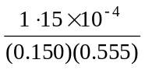 1
= 1.38 × 10–3 to 1.4 × 10–3 1
mol–1dm3s–1 1
(b) ans = rate constant × (½ × 0.150) × (½ × 0.555) 1
ignore units
= rate constant × 0.0208
2.88 × 10–5 (1.38 × 10–3 gives 2.87 × 10–5)
Allow 2.87 – 2.91 × 10–5 (1.4 × 10–3 gives 2.91 × 10–5)
[4]
3. (a) order with respect to P is 2 1
order with respect to Q is 1 1
(b) (i) rate = k[R][S]2 (if wrong expression, no further marks) 1
rate = (4.2 × 10–4) × 0.16 × 0.842 1
= 4.7 × 10–5 (mol dm–3 s–1) ignore units even if wrong 1
(ii) 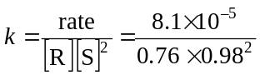 1
= 1.1 × 10–4 * 1
(iii) T1 1
∗If calculated value for k > 4.2 × 10–4, then answer to (iii) is T2
[8]
4. (a) (i) Experiment 2 2.60 × 10–3 1
Experiment 3 0.60 × 10–2 1
Experiment 4 11.4 × 10–2 1

(ii) k = 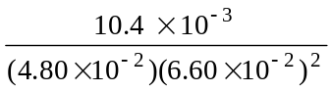 1
= 49.7 1
(Allow 49.8 and 50)
mol–2 dm6 s–1 1

(b) No change 1
[7]
5. (a) Order with respect to iodine: 0 (1)
Overall order: 2 (1) 2

(b) Rate constant: k = 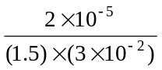 = 4.4(4) × 10–4 (1)
Units: mol–1 dm3 s–1 (1) 3

(c) Appears in rate equation (1)
OR implied by mention of concentration or order
does not appear in (stoichiometric / overall) equation (1) 2

[7]
6. (a) (i) change in concentration / amount / mass / volume / (partial) pressure
per unit time / per s (1) 1
(ii) constant of (proportionality) in the rate equation (1)
allow reference to k in rate equation 1
(iii) sum of
dependent on 2nd mark or reference to ‘orders’ (1)
powers in rate equation (1)
allow reference to annotated rate equation 2
(b) (i) (H2) – 1 (1)
eg rate trebles as [H2] trebles not rate doubles as [H2] doubles (1)
(I2) – 1 (1)
eg rate doubles as [I2] doubles (1)
mark these points independently
allow 1 mark for orders if not clear that both are first order 4
(ii) rate = k[H2][I2] (1)
must be [H2] not [H]
allow e.c.f from (b)(i)
allow mark for correct answer for (b)(ii), even if (b)(i) wrong 1
(iii) rearrange correctly (1)
correct substitution and correct consequential answer (1)
correct units (mol–1 dm3 s–1) (1)
allow e.c.f. from (b)(ii)
allow e.c.f. for incorrect arrangement 3
(c) 4 × 10–6 (1)
allow e.c.f. from (b)(ii) and (b)(iii)
could be worked by ratio from values in table or from rate equation 1
[13]

